- Purpose
  - The purpose of this document is to describe the procedure for assembling the Orbital Head on the Genesys Machine.
- Scope
  - This SOP applies to all equipment assembly team members. The process applies to the following machine ID’s:
EP50322EQS0600BE1200 – Orbital Head Assembly
- Responsibilities
  - The operations manager/supervisor is responsible for enforcing this SOP.
- Materials
  - The proper materials needed for this process are listed on the machine work order.
- Definitions

- Procedure
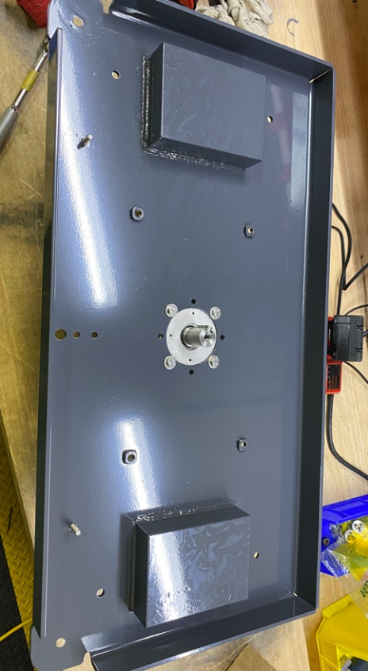
  - Place a motor (E28521) onto the table with the shaft pointing up. Point the wires towards the back of the table.
  - Place the base (E28518) on the motor in the orientation shown and attach it using 4 bolts (E83914) and 4 flat washers (E28617). Use Blue Loctite on the threads. Tighten the bolts to 7ft-lbs min. Mark the orientation of the bolt heads once complete.
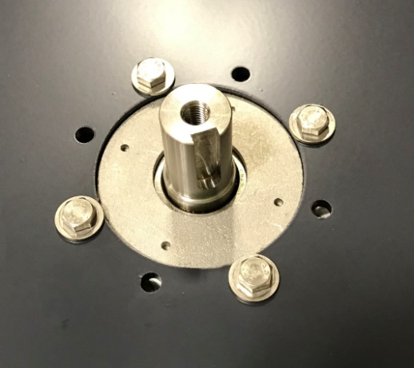
Motor wires point this direction

  - Place a machine key (E28635) into the motor shaft.
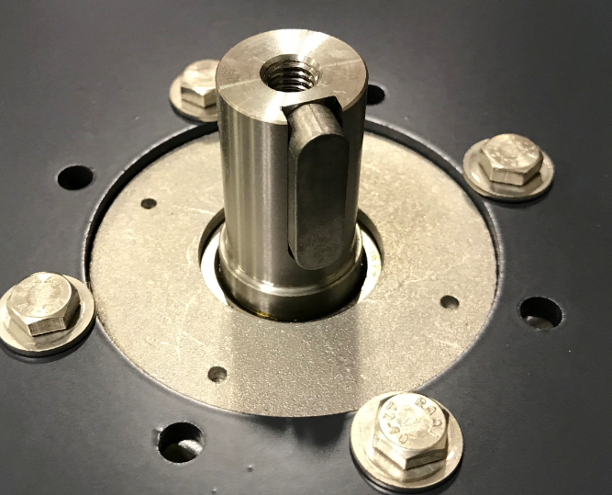
  - Place some anti-seize on the motor shaft. Place a bearing/counterweight assembly (refer the proper SOP for assembly instructions) onto the motor shaft and attach it using a hub washer (E28631) and a hex bolt (E29426). Use Blue Loctite on the threads. Using the blue torque gun with ½” socket tighten the bolt to 15 ft-lbs min. A green light will appear when torque is good, if red light appears removed bolt repeat process. Mark the orientation of the bolt head.
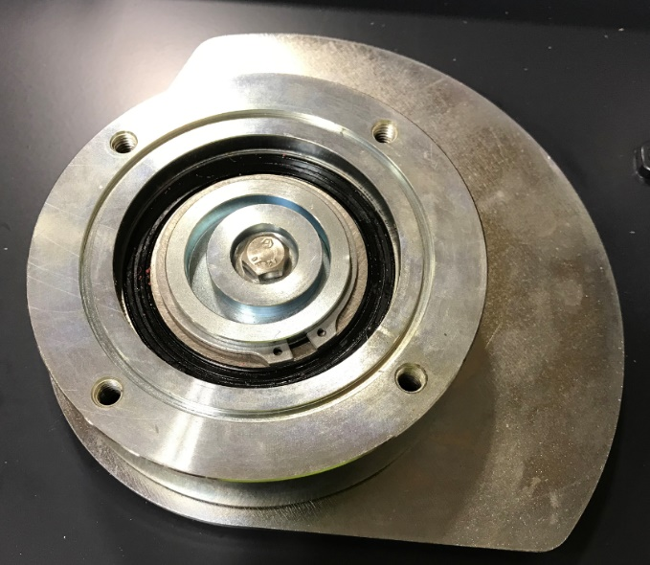
  - Take a water feed manifold (E28533) and press a hole plug (E28535) into each end of it.
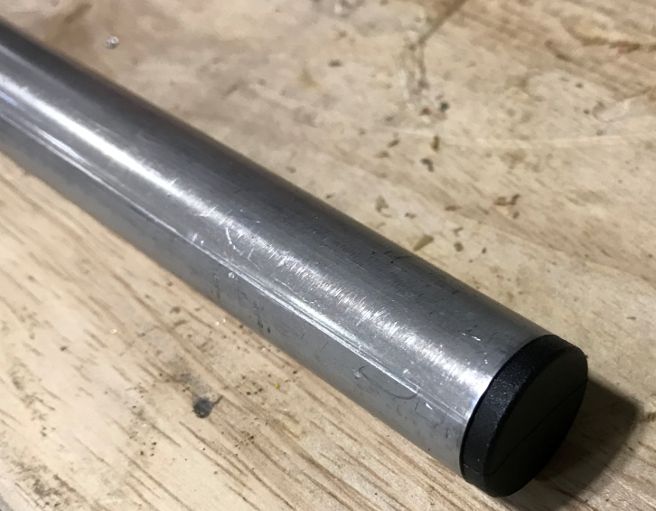

  - Before attaching the manifold, run a die over the 2 studs on the deck. The threads can be damaged or have paint on them. Attach the manifold to the base with 2 loop clamps (E28534) and 2 nylock nuts (E28853). The center feed port should line up with the large hole in the base. To help with alignment, you may want to use a barbed elbow and put it through the deck and into the tube. Ensure that the holes in the manifold are oriented properly. When the center hole is aligned, they should slightly point towards the front of the deck.
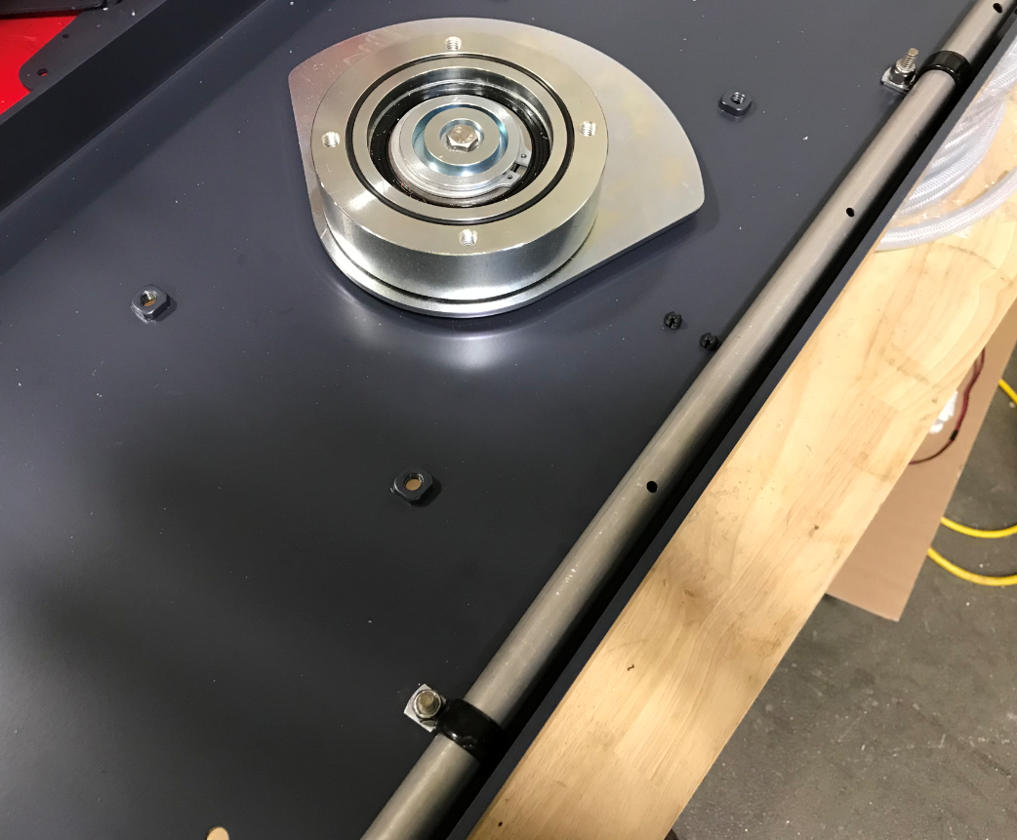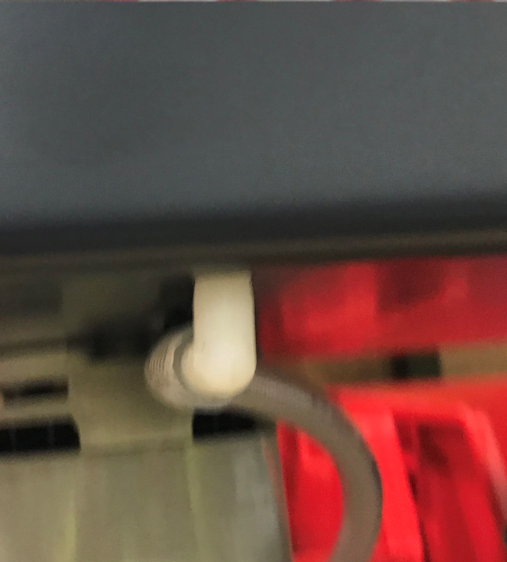
Barbed Elbow
Holes should be angled slightly towards the front
  - Attach 2 bumper casters (E28509) to the weldment in the appropriate locations. Put a bushing (supplied with the wheel) into the ID of the wheel. Sandwich a spring washer (E28640) between the wheel and the plate. Use a flat head screw (E28634), a washer (E28622), and a nylock nut (E28623) to attach the wheel. Ensure the wheel still spins once installed.
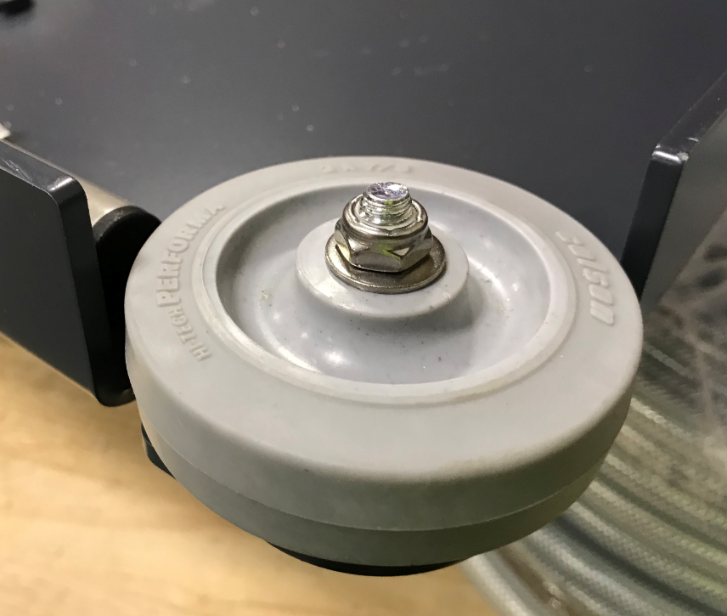
  - Take 4 isolators (E28530) (drill out holes of isolators before installation to clean them out) and place a spacer (E28633) over the threaded stud on each one. Attach the isolators to the deck by putting the studs through the appropriate holes and attaching them using a nylock nut (E81063) and a flat washer (E28622).
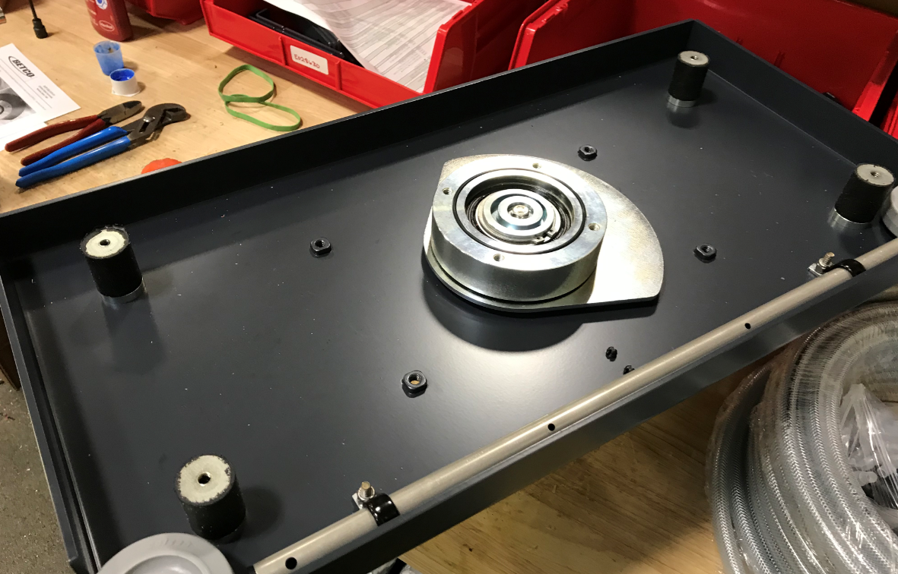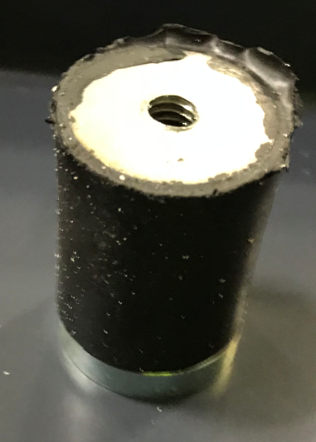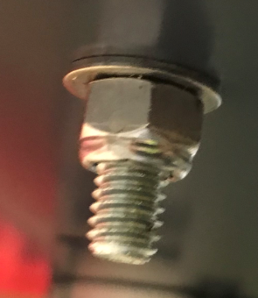
  - Place an o-ring (E28527) into the groove on the orbital bearing hub.
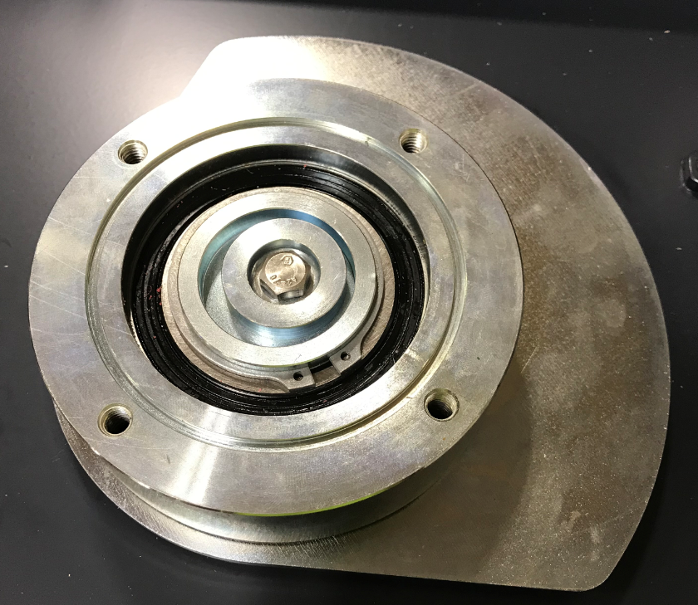
O-Ring goes in this groove

  - Place an orbital pad driver plate (E28526) into position and attach it. Use 4 flat head screws (E28763) to attach the plate to the bearing assembly. Then, use 4 flat head screws (E28639) to attach the plate to the isolators. Use Blue Loctite on all threads.
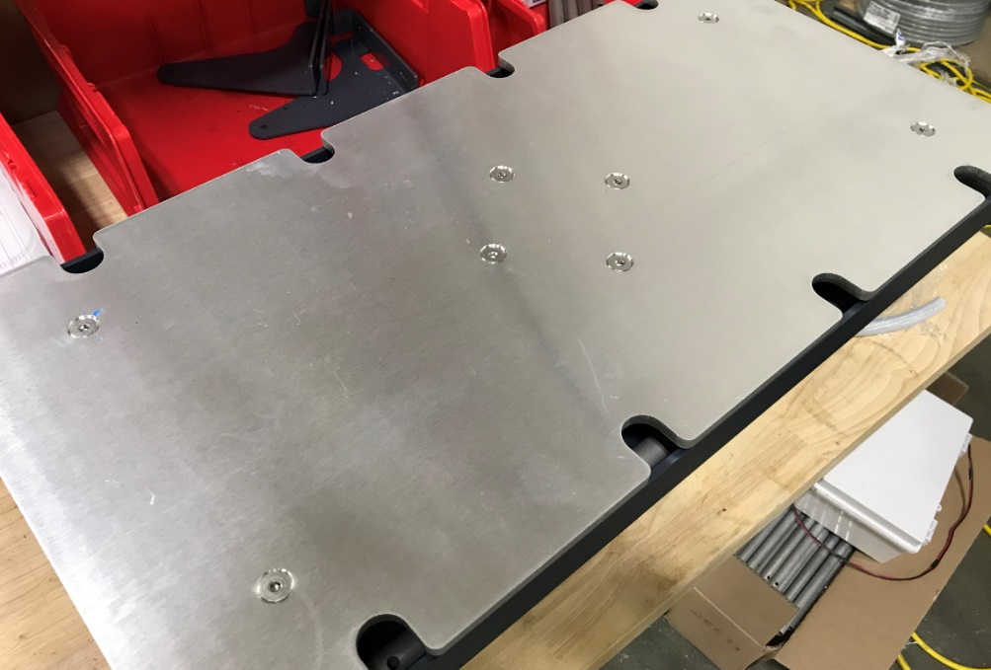
  - Stick a pad driver face (E28513) to the plate followed by a red pad (E89832).
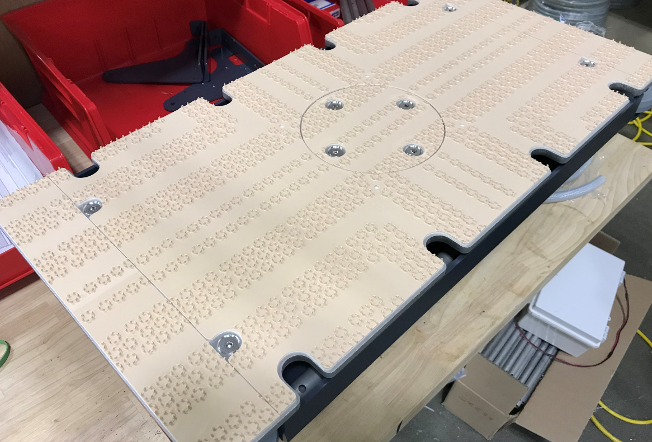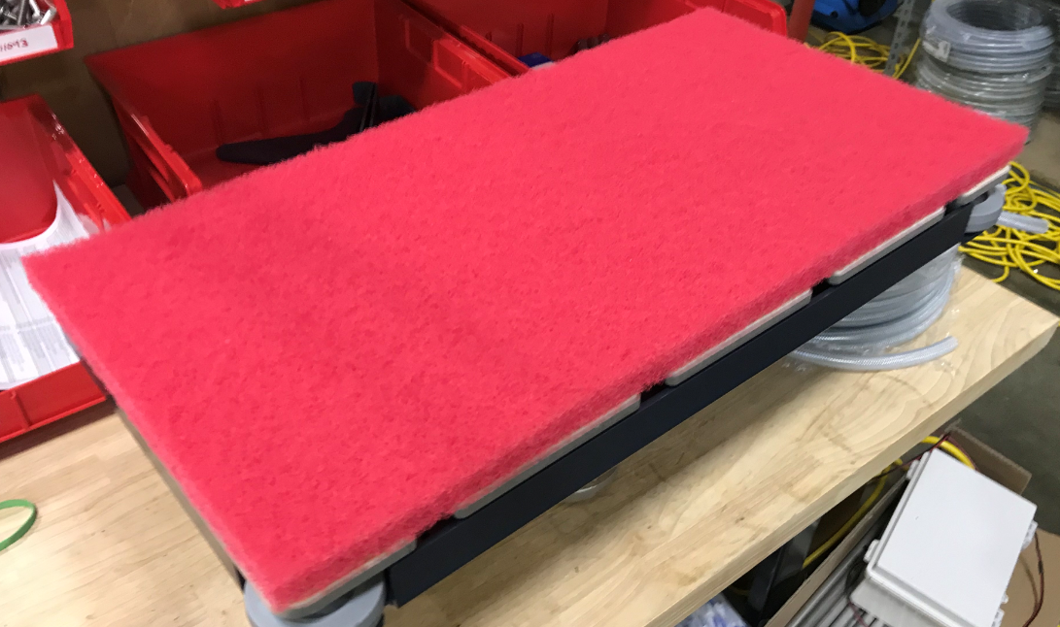
  - Flip the base over.

  - Push 2 wire tie mounts (E28621) into the appropriate holes on the weldment next to the watering port.
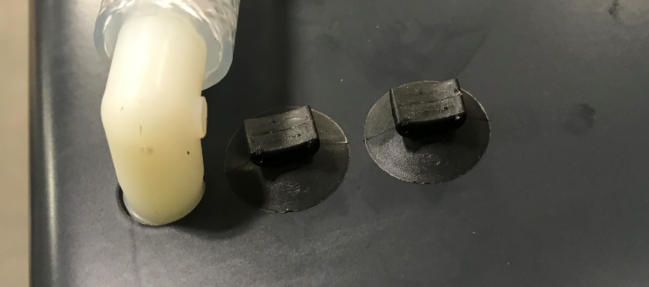
  - Cut a 24” piece of 3/8” hose (E28620). Press the hose onto the end of a plastic elbow (E28536) and install the other end of the elbow into the top side of the manifold.
  - Secure the hose and elbow with 2 zip ties (E83523).
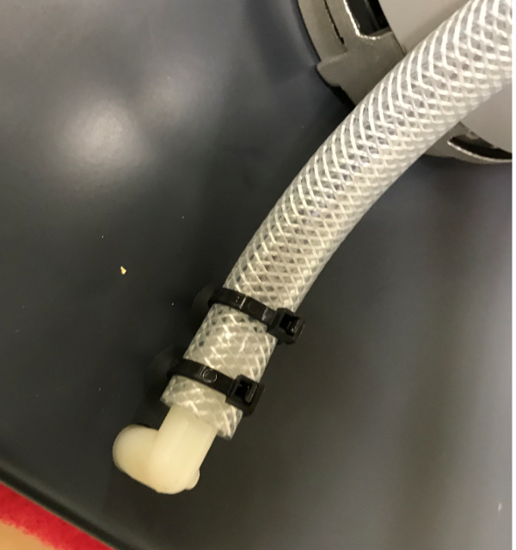
  - Place an orbital head lift bracket (E28650) on the table. Look at the threads on the studs and run a die over them to clean them up if needed.
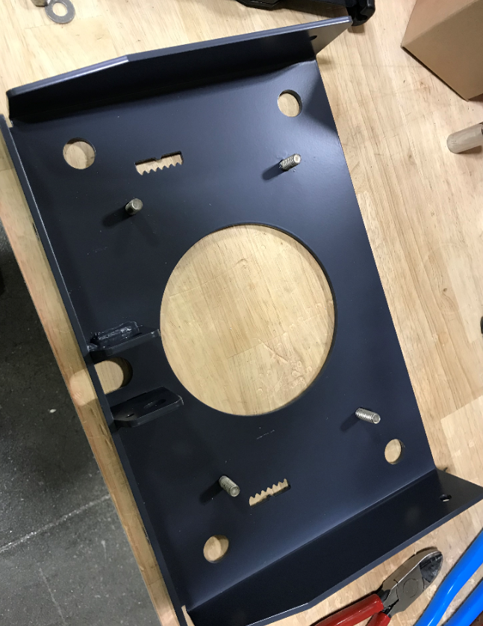
  - Take a left-hand head bracket (E28630) and verify with the picture that the bracket is facing correctly. Then feed a carriage bolt (E11043) through the front hole. Attach the bracket to the studs on the head lift bracket using 2 flat washers (E28622) and 2 nuts (E81063). Leave the nuts loose at this point.
  - Repeat the process for the right-hand head bracket (E28653).
  - Tie the head lift bracket to the roller brackets on the front using a flat washer (E28622) and a nut (E81063) on each. Leave it loose at this point.
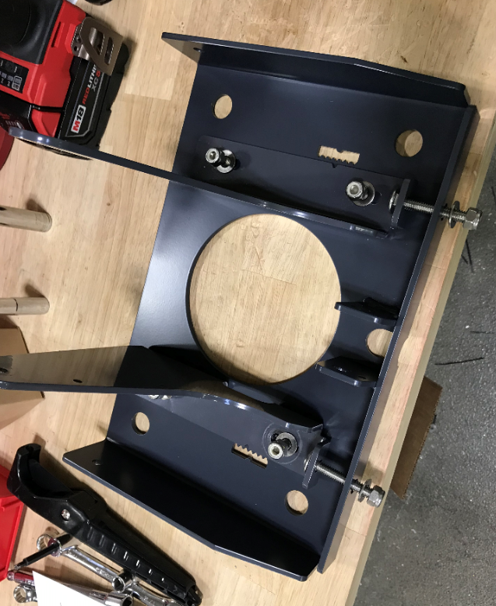
  - Press an isolator (E28531) into the top and bottom of each of the 4 mounting holes.
  - Press an isolator bushing (E28656) through each pair.
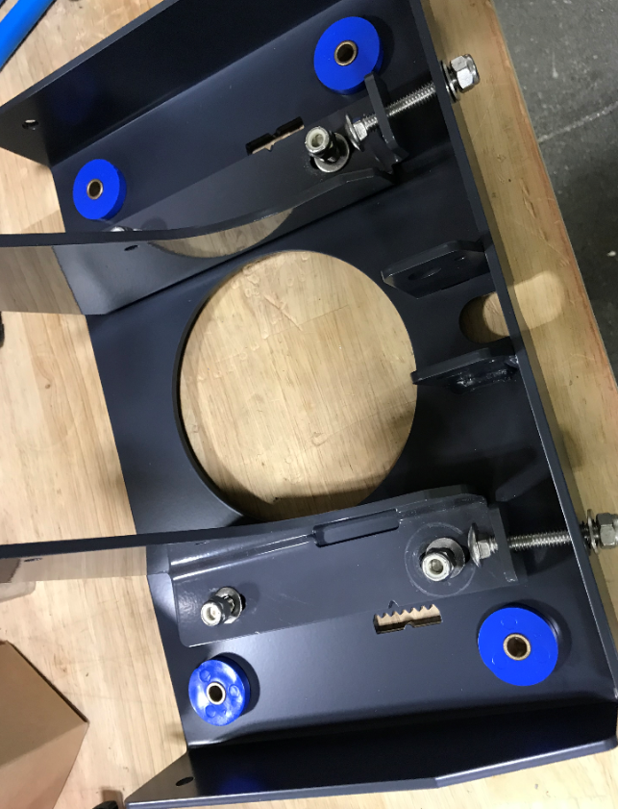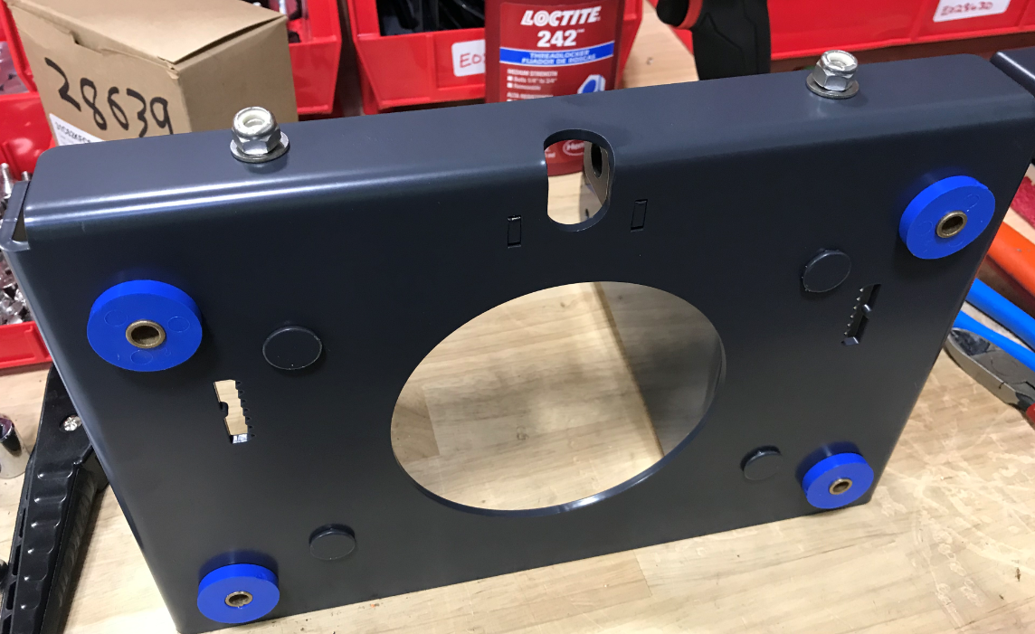
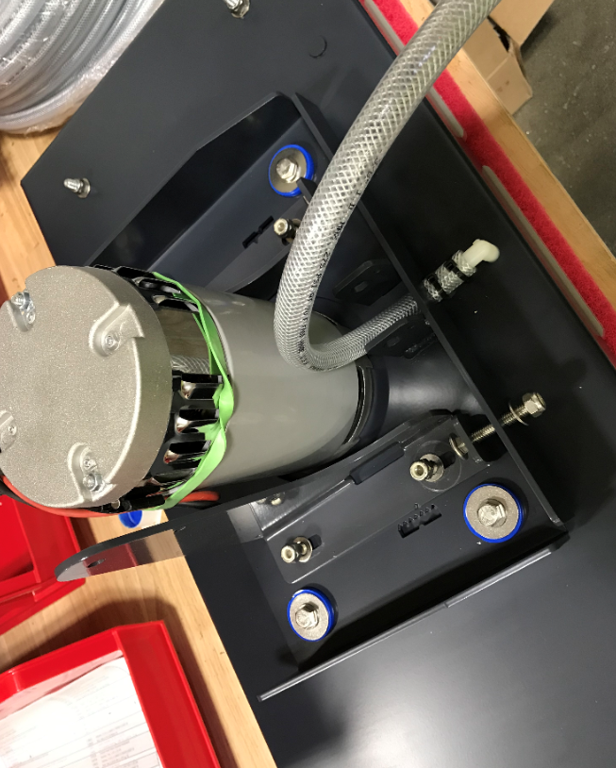
  - Lay the head lift bracket assembly onto a motor bracket weldment (E28518) and attach it using 4 hex bolts (E29553), 4 large washers (E28764), and 4 flat washers (E28622). Use Blue Loctite on the bolt threads. Tighten until the isolators start to mushroom. Fish the wires and the hose through the openings in the plate.

- References (optional section as needed)

- Training Guide

Functional Training Groups Requiring Training
Equipment Assembly Group

- SOP Change Control

Date of Change | Reason for Change
TBD | This is the first version of the S.O.P. hence there are no revisions to this document.
8/13/2021 | Added QC Checks and bolt torques
11/6/2023 | Updated to current process
8/1/2024 | Added Blue Loctite symbol to steps
4/2/2025 | Updated formatting and process

Approvals

Submitter/Author Approval:__________________________________ Date:______________________

Management Approval:______________________________________ Date:______________________

QAU Approval:_____________________________________________ Date:______________________

